Assignment 3: Programming in Python CST 362

Name: **Alby Thekkedan Roll No 8 Class CS6B**

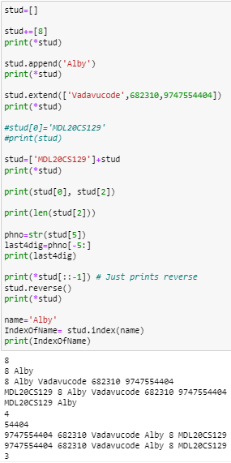KTU-ID: **MDL20CS129**

Date of submission: 15-March-2023

**Learning outcome: Learn list, tuple and set**

1. Write commands for the following

a. Create an empty list (stud)

b. Add your roll number to the list (use + operator)

c. Append your name (use append)

d. Extend the list with your place, pin, number (extend)

e. Insert your KTU-ID at stud [0]

f. Print your KTU-ID and name

g. Print the number of characters in your name.

h. Print last 5 digit of the phone number

I. Reverse the stud list

j. Find the index of your name.



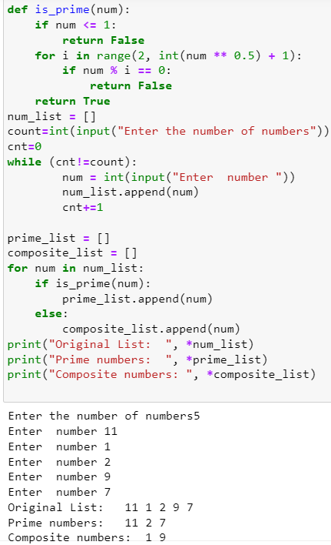2. Read list of numbers and store it in a list. Create two new lists from the list created which contains prime and composite numbers.



3. Read list of students names and do the following

a) Sort the name in alphabetical order

b) Find the name with largest length

c) print the names starting with letter ‘A’ ( assume first letter capital)

d) Print the names in reverse alphabetical order with all names converted to capital letters.

e) Print the names in the order of length

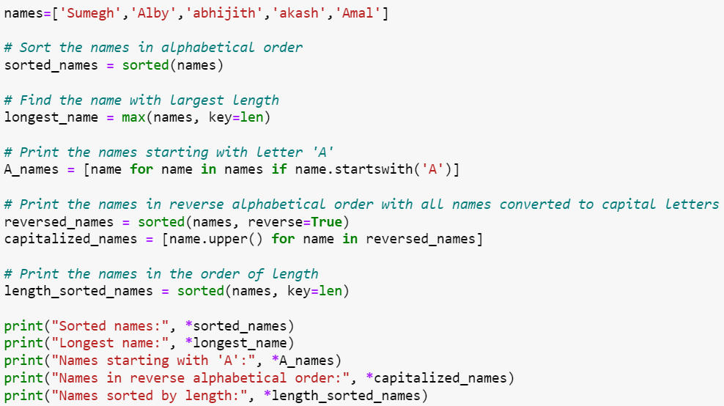

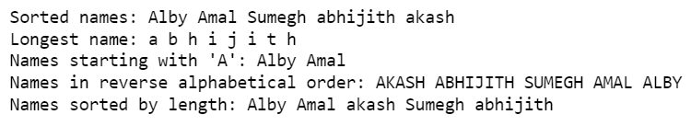

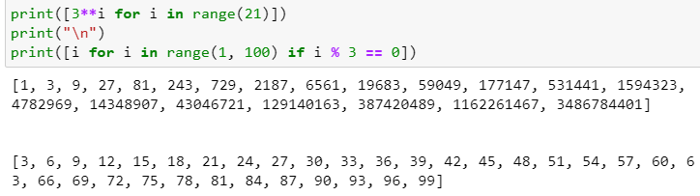

4. Use list comprehension to create lists

a)powers of 3 upto 20

b) Numbers less than 100 which are divisible by 3

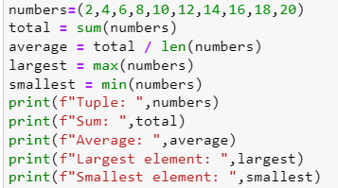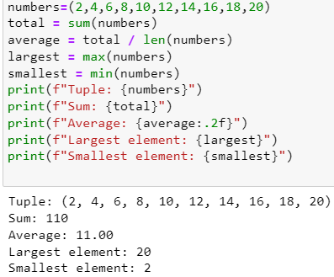5. Read 10 numbers and stores it in a tuple. Find the sum, average of these elements also find the largest and smallest.

6. Read the sets. Find the union, intersection and symmetric difference of two sets A and B.

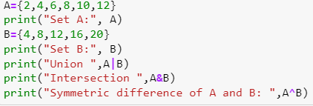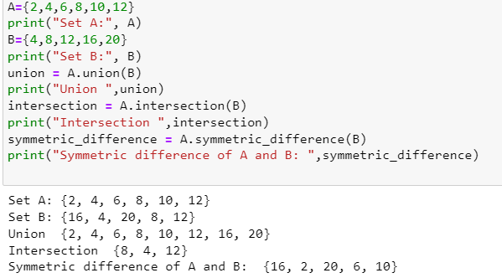

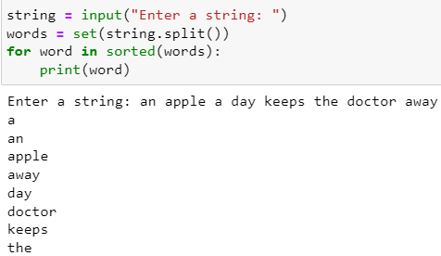7. Read a string and print the words in alphabetical order.



8. Read a string and print the words and its length. Also find the average word length.

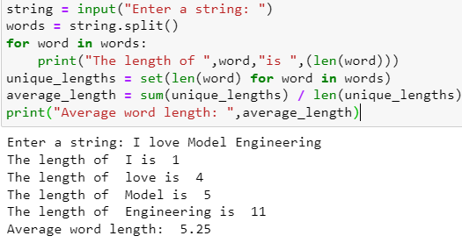

9. Read list of numbers and find the mean, median and standard deviation.

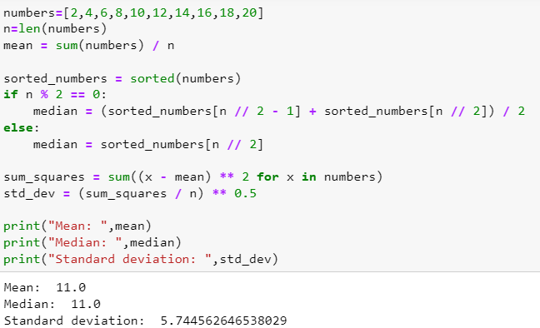

10. Consider a list consisting of integers, floating point numbers and strings. Separate them into different lists depending on the data types.

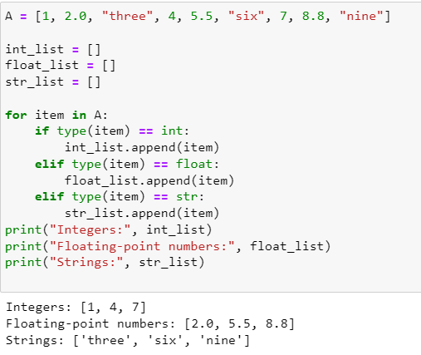



11. Check if the items in the list are sorted in ascending or descending order and print suitable messages accordingly. Otherwise, print “Items in list are not sorted”

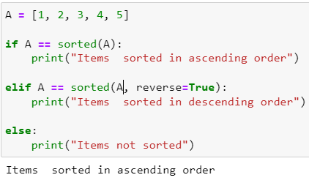

12. Remove all duplicate elements from a list

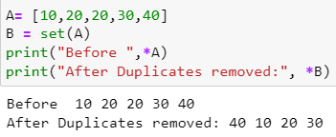

13. Find the number with largest frequency of occurrence. i/p:10 20 30 40 40 40 50 50 o/p:40 ( Note: there may be more than one element)

